**Project Development Phase**

**Sprint-1**

|  |  |
| --- | --- |
| Date | 15 November 2022 |
| Team ID | PNT2022TMID45183 |
| Project Name | AI Based Discourse for Banking Industry |
| Maximum Marks | 4 Marks |

Create Watson Assistant

In this phase we are create the Watson assistant in IBM Cloud

**Create the N**

**ew Skills**

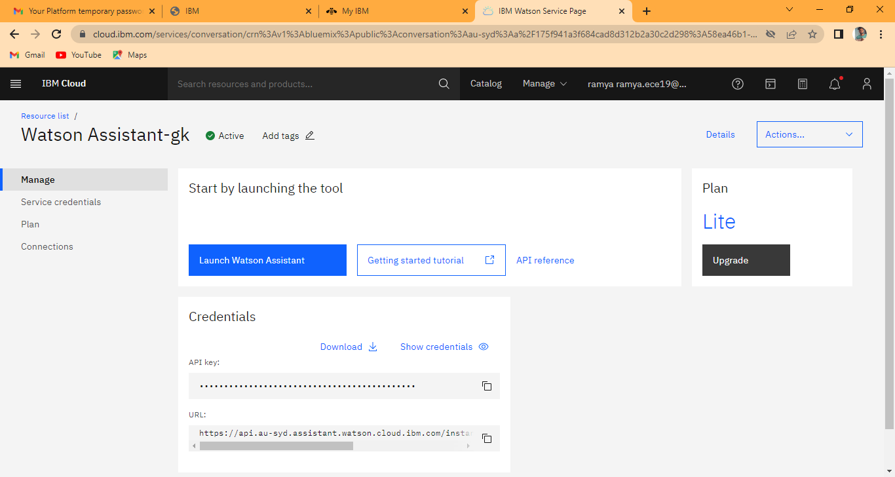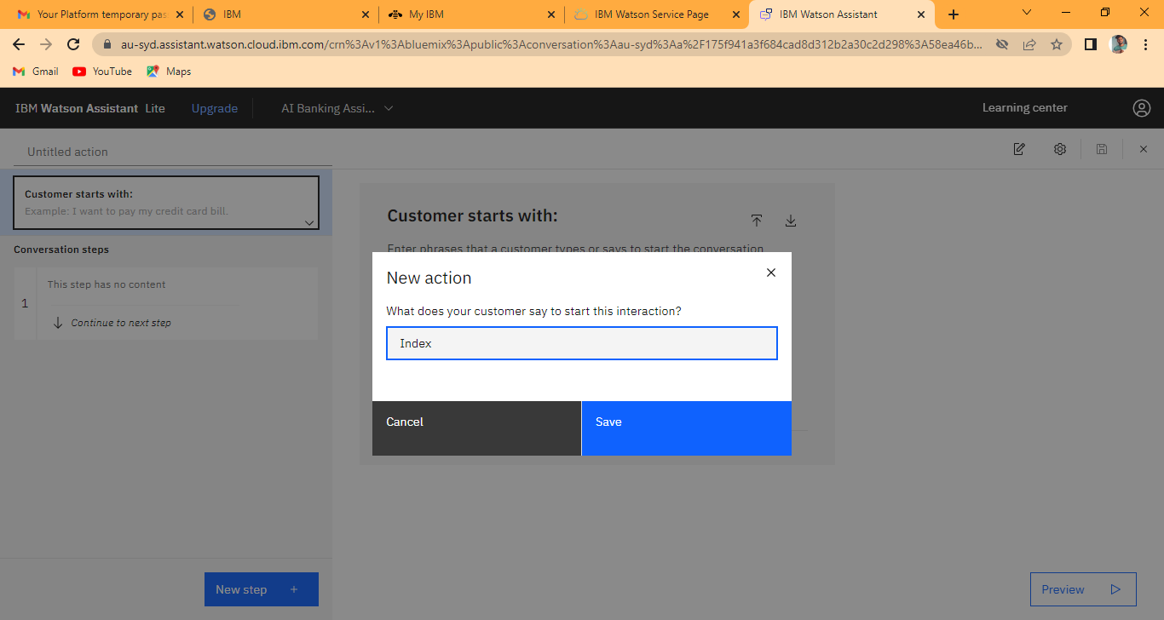

**Preview**

